

<!DOCTYPE html>

<html lang="en">

<head>

<meta charset="UTF-8">

<meta name="viewport" content="width=device-width, initial-scale=1.0">

<title>Document</title>

<style>

@font-face {

font-family: 'oswald';

src: url('Oswald-VariableFont_wght.ttf');

font-family:'summer';

src: url('/Summer\ Dream\ Sans\ DEMO\ .ttf');

}

body {

margin: 0;

padding: 0;

font-family: Arial, sans-serif;

background-color: #f0f0f0;

}

#one {

font-family: oswald;

background-color: #11201e;

text-align: center;

color: #d5e9dd ;

padding: 20px;

}

#one h1 {

font-size: 50px;

font-family: summer;

}

#one img{

height: 100px;

}

#two {

display: flex;

justify-content: space-between;

background-color: #154042 ;

padding: 5px;

border-radius: 10px;

}

#two a {

text-decoration: none;

color: #d5e9dd ;

padding: 10px 20px;

}

#videos {

background-color: #d5e9dd ;

padding: 20px;

color:#333;

}

#videos video {

width: 100%;

max-width: 100%;

height: auto;

margin: 20px 0;

border-radius: 5px;

}

a:hover{

color:crimson;

}

</style>

</head>

<body>

<div id="one">

<img src="/Screenshot (43).png">

<div id="two">

<a href="index.html"><h2>HOME</h2></a>

<a href="reg.html"> <h2>REGISTRATION</h2></a>

<a href="gal.html"><h2>GALLERY</h2></a>

</div>

<div id="videos">

<h1>

EXPERIENCE

</h1>

<video src="/2.mp4" autoplay loop></video>

<H1>

LIFE

</H1>

<video src="/1.mp4" autoplay loop></video>

<h1>

LIKE

</h1>

<video src="/3.mp4" autoplay loop></video>

<h1>

NEVER BEFORE

</h1>

<video src="/4.mp4" autoplay loop></video>

</div>

</body>

</html>

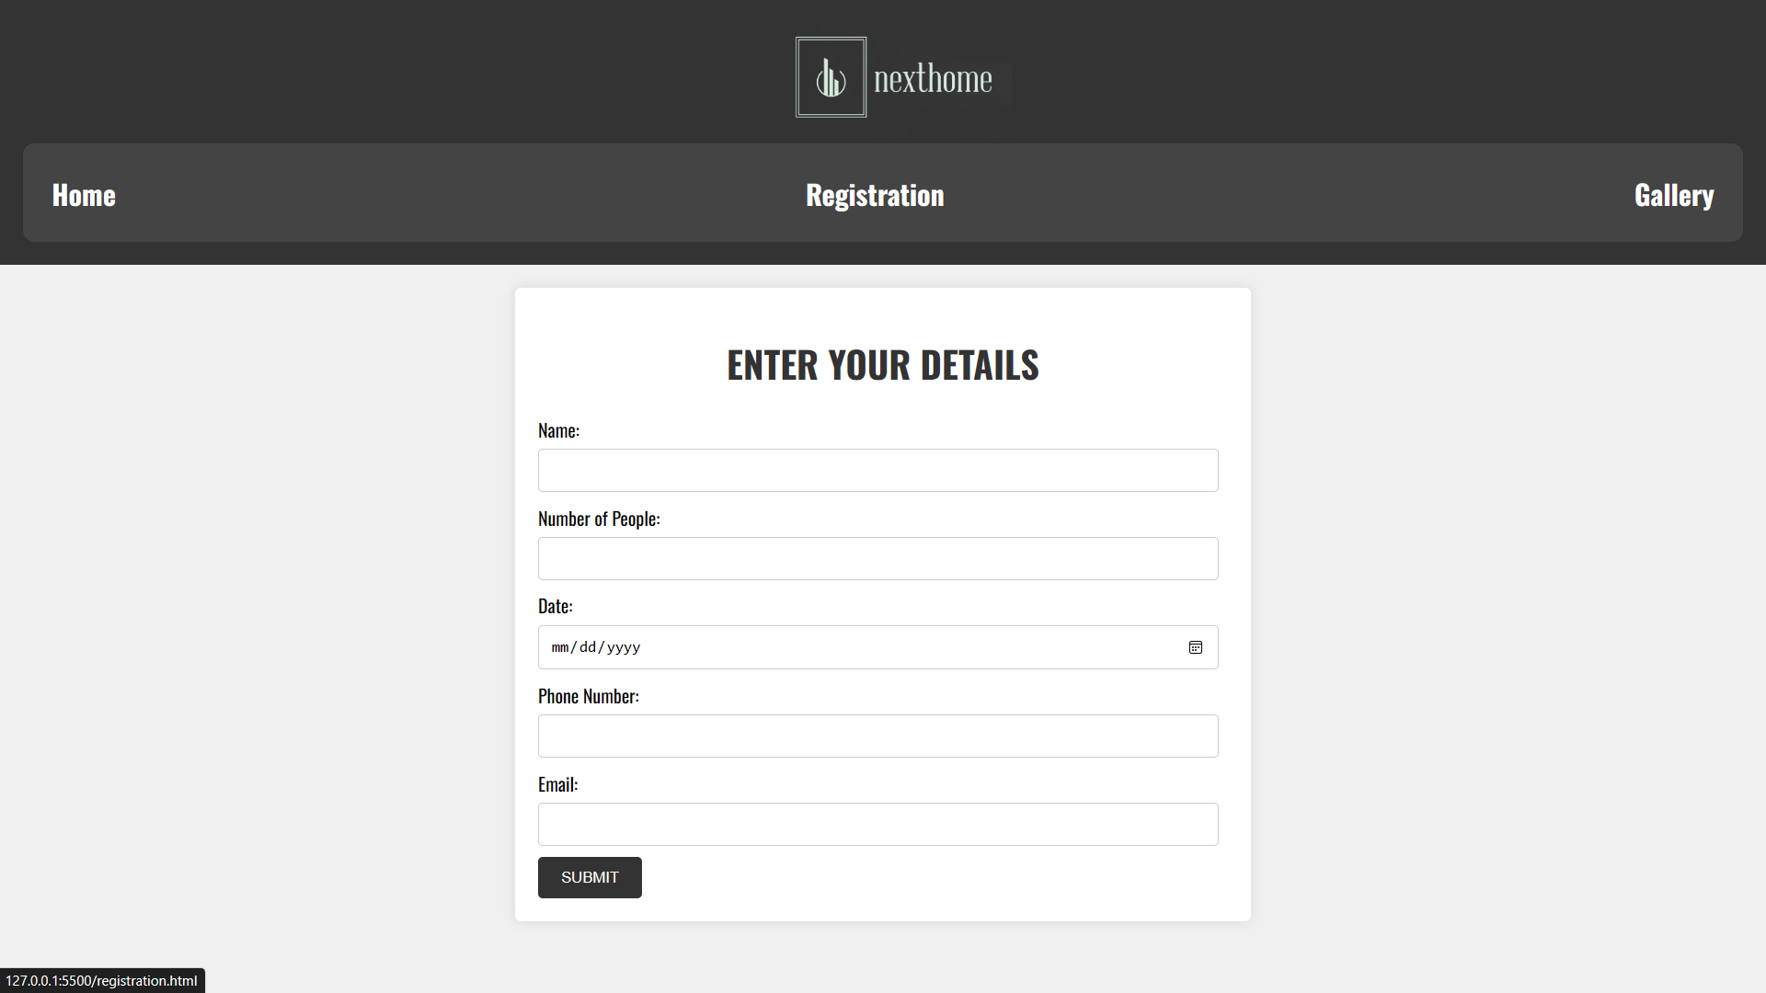

<!DOCTYPE html>

<html>

<head>

<title>REGISTRATION</title>

<style>

body {

font-family: Arial, sans-serif;

background-color: #f2f2f2;

font-family: oswald;

}

.container {

max-width: 600px;

margin: 0 auto;

padding: 20px;

background-color: #fff;

box-shadow: 0 0 10px rgba(0, 0, 0, 0.1);

border-radius: 5px;

}

h1 {

text-align: center;

color: #333;

}

form {

margin-top: 20px;

font-family: oswald;

}

label {

display: block;

font-weight: bold;

margin-top: 10px;

}

input[type="text"],

input[type="number"],

input[type="date"],

input[type="tel"],

input[type="email"] {

width: 95%;

padding: 10px;

margin-top: 5px;

margin-bottom: 10px;

margin-right: 10px;

border: 1px solid #ccc;

border-radius: 4px;

}

input[type="submit"] {

background-color: #333;

color: #fff;

padding: 10px 20px;

border: none;

border-radius: 4px;

cursor: pointer;

}

input[type="submit"]:hover {

background-color: #ba5454;

}

#one{

font-family: oswald;

background-color: red;

text-align: center;

text-decoration: none;

}@font-face {

font-family: 'oswald';

src: url('Oswald-VariableFont_wght.ttf');

font-family:'summer';

src: url('/Summer\ Dream\ Sans\ DEMO\ .ttf');

}

body {

margin: 0;

padding: 0;

font-family: Arial, sans-serif;

background-color: #f0f0f0;

}

#one {

font-family: oswald;

background-color: #333;

text-align: center;

color: #fff;

padding: 20px;

}

#one img{

height: 100px;

}

#one h1 {

font-size: 50px;

color: #ccc;

font-family: summer;

}

#two {

display: flex;

justify-content: space-between;

background-color: #444;

padding: 5px;

border-radius: 10px;

}

#two a {

text-decoration: none;

color: #fff;

padding: 10px 20px;

}

</style>

</head>

<body>

<div id="one">

<img src="/Screenshot (43).png">

<div id="two">

<h2><a href="index.html">Home</a></h2>

<h2><a href="registration.html">Registration</a></li></h2>

<h2><a href="gal.html"> Gallery</a></li></h2>

</div>

</div>

<form action="phpend.php" method="POST">

<div class="container">

<h1>ENTER YOUR DETAILS</h1>

Name:

<input type="text" id="name" name="name" required>

Number of People:

<input type="number" id="party-size" name="party-size" required>

Date:

<input type="date" id="date" name="date" required>

Phone Number:

<input type="tel" id="phone" name="phone" required>

Email:

<input type="email" id="email" name="email" required>

<input type="submit" value="SUBMIT">

</form>

<div id="confirmation" style="display: none; text-align: center;">

<p>Your reservation information has been updated.</p>

</div>

</div>

<script>

document.getElementById("reservation-form").addEventListener("submit", function(event) {

event.preventDefault(); // Prevent the default form submission

document.getElementById("confirmation").style.display = "block"; // Display the confirmation message

});

</script>

<script>

function onHover(element) {

element.style.backgroundColor = "#eee";

}

function onBlur(element) {

element.style.backgroundColor = "#fff";

}

document.getElementById("name").addEventListener("mouseover", function() {

onHover(this);

});

document.getElementById("name").addEventListener("mouseout", function() {

onBlur(this);

});

document.getElementById("party-size").addEventListener("mouseover", function() {

onHover(this);

});

document.getElementById("party-size").addEventListener("mouseout", function() {

onBlur(this);

});

document.getElementById("date").addEventListener("mouseover", function() {

onHover(this);

});

document.getElementById("date").addEventListener("mouseout", function() {

onBlur(this);

});

document.getElementById("phone").addEventListener("mouseover", function() {

onHover(this);

});

document.getElementById("phone").addEventListener("mouseout", function() {

onBlur(this);

});

document.getElementById("email").addEventListener("mouseover", function() {

onHover(this);

});

document.getElementById("email").addEventListener("mouseout", function() {

onBlur(this);

});

document.getElementById("reservation-form").addEventListener("submit", function(event) {

});

</script>

</body>

</html>

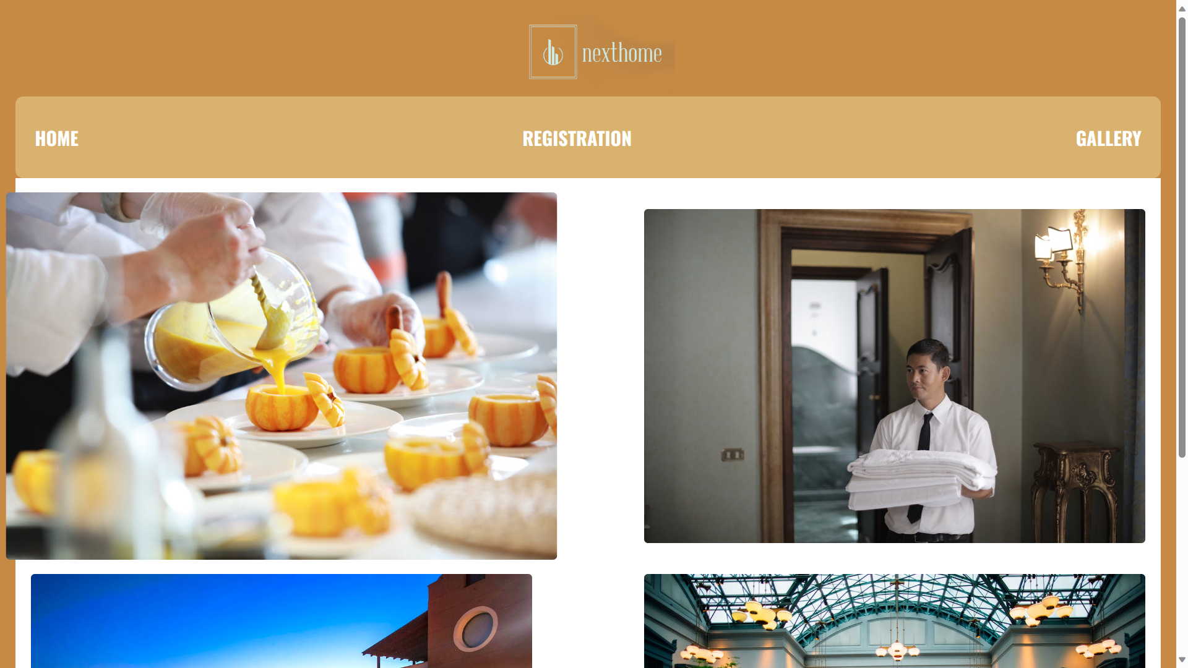

<!DOCTYPE html>

<html lang="en">

<head>

<meta charset="UTF-8">

<meta name="viewport" content="width=device-width, initial-scale=1.0">

<title>Document</title>

<style>

@font-face {

font-family: 'oswald';

src: url('Oswald-VariableFont_wght.ttf');

font-family:'summer';

src: url('/Summer\ Dream\ Sans\ DEMO\ .ttf');

}

body {

margin: 0;

padding: 0;

font-family: Arial, sans-serif;

background-color: #f0f0f0;

}

#one {

font-family: oswald;

background-color: #c78a44;

text-align: center;

color: #fff;

padding: 20px;

}

#one h1 {

font-size: 50px;

font-family: summer;

}

#two {

display: flex;

justify-content: space-between;

background-color: #d8b26e ;

padding: 5px;

border-radius: 10px;

}

#two a {

text-decoration: none;

color: #fff;

padding: 10px 20px;

}

#videos {

background-color: #fff;

padding: 20px;

color: #333;

display: flex;

flex-wrap: wrap;

justify-content: space-between;

}

#videos img {

width: 45%;

max-width: 100%;

height: auto;

margin: 20px 0;

border-radius: 5px;

transition: transform 0.3s;

}

#videos img:hover {

transform: scale(1.1);

}

#ok{

height: 100px;

}

</style>

</head>

<body>

<div id="one">

<img src="/Screenshot (43).png" id="ok">

<div id="two">

<a href="index.html"><h2>HOME</h2></a>

<a href="reg.html"> <h2>REGISTRATION</h2></a>

<a href="gal.html"><h2>GALLERY</h2></a>

</div>

<div id="videos">

<img src="/1.jpg" autoplay loop></video>

<img src="/2.jpg" autoplay loop></video>

<img src="/3.jpg" autoplay loop></video>

<img src="/pexels-kelly-2869215 (1).jpg" autoplay loop></video>

</body>

</html>